Question:
In the project description, you mentioned that we should upload a .R file as well as a Google Doc. All uploaded documents (including data files, etc.) should have your firstName_lastName_Project as part of the file name.
What exactly does "All documents" mentioned here include? Is there a written report?
My understanding is that we should at least upload the R file, the google doc file of "All code", the data file, and the recording file.
May I ask if there are any other files that we need to upload?

Answer:
As with the homeworks, your .R file is your main project/report and should contain your full step-by-step analysis in tutorial form using alternating comments, explanations, and code. In other words, the .R file itself should function as the report by walking the reader through your thought process, methods, and conclusions from beginning to end.

The Google Doc is not intended to be a separate formal report. Similar to the homeworks, it should be a shared copy of that same .R file/report so that it is easier to view, highlight, and comment on.

So, at minimum, your project submission should include:
- Your .R file (your primary project/report)
- Your Google Doc (shared version of that same .R report)
- Your data file(s)
- Your project presentation recording file

If you have additional project-related files (for example, cleaned datasets or supplementary materials), you can include those as well and use the same naming convention.

So for most students, the four files you listed are exactly what is expected but depending on what you do for the project, you may want to add other relevant files.

Question:
I started working with a database San Francisco salaries from the Kaggle datasets. I am having issues running lot of functions on the dataset as the number of observations is 148654.
For example:

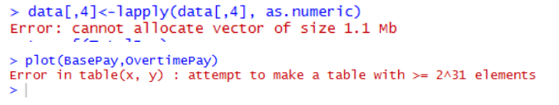
Is it okay if we truncate the datasets or is it like it must be kept the same?

Answer:
Try to logically create a smaller data set.
For example, choose a random subset of the data so your new data may be representative or aggregate the data in some way like taking daily data and working with the average of every for each month (working with monthly data instead).
Be creative and logical - if all else fails then you may truncate it but of course explain exactly what you did in your analysis.

Question:
I have downloaded a data with ? meaning NA. However, na.strings="?" or data=="?" cannot find any ? which is obviously viewed? Do you have any idea how this happened?

Answer:

You may find the trim() function from the gdata library to be useful:
library(gdata)
s <- " this is an example string "
trim(s)

